Step 1)

First locate the pom.xml file.

Inside the pom.xml file right click and click.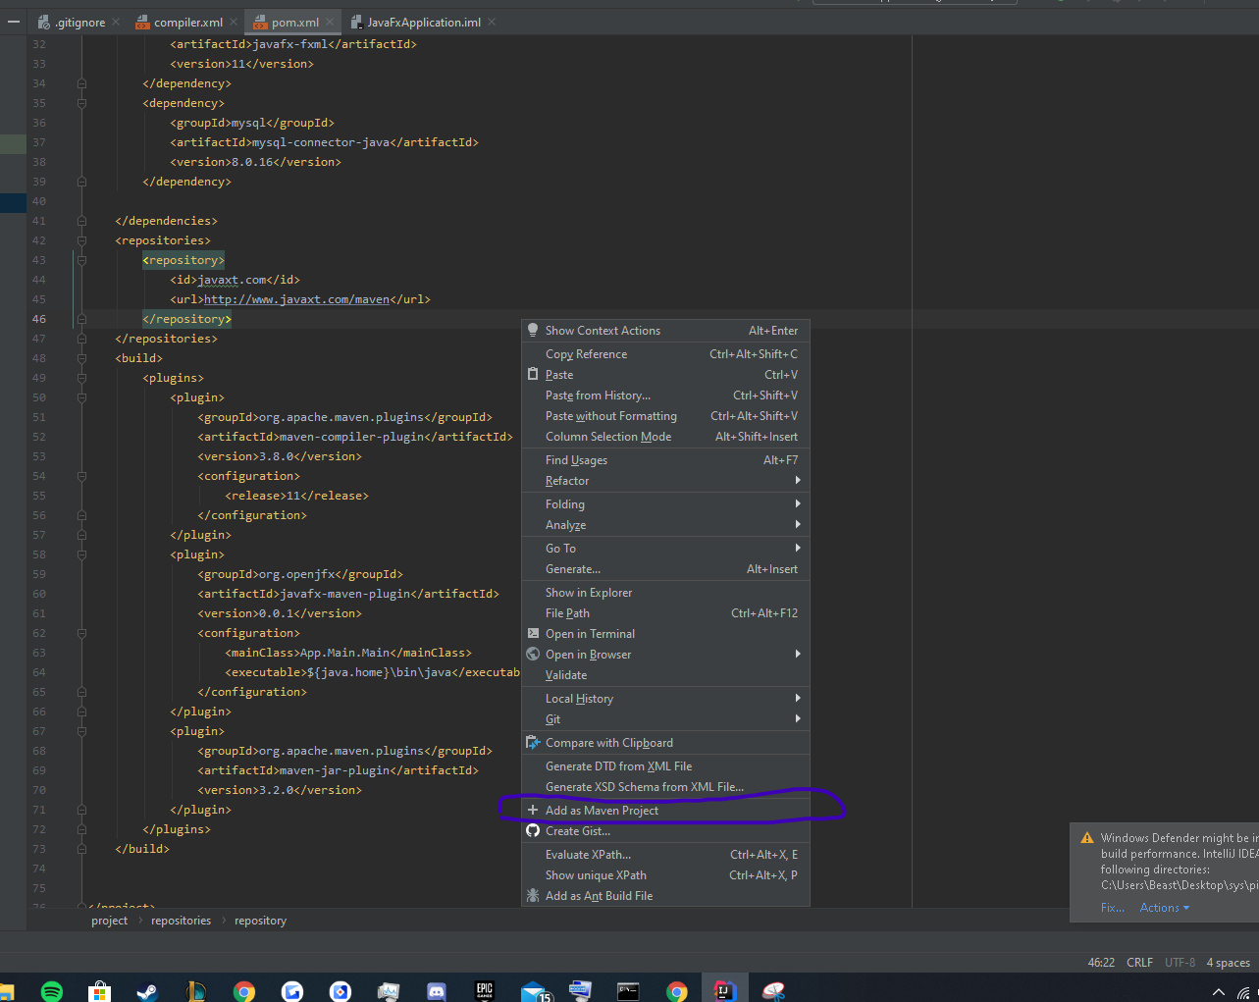

After you do this maven will download all the dependencies you need to run the project. When this Is happening a maven window will pop up if so, go straight to step 3 to run the program

Step 2)

If you don’t get the maven pop up or can’t find it. Go to view then tool windows and then maven

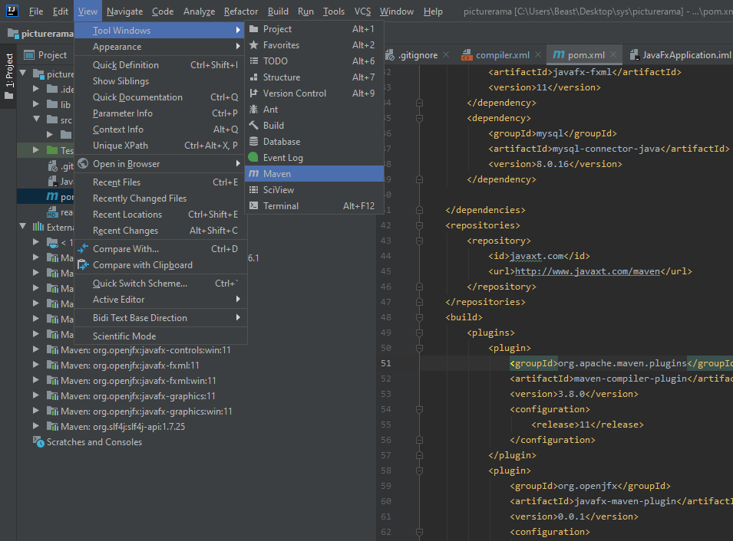

Step 3)

To run the program, you first need to compile it with maven javafx locate the javafx compiler plugin and click then click the green hammer in intelliJ. after that right click javafx:run and hit “run JavaFxApplication” this will set your run button in intellij to run the project. If during development u run into any problems, try to recompile the project. Also use build In IntelliJ to debug your program You might also have to manually recompile the project after making changes. Important that you use the build feature in IntelliJ before you try to run the program. Because maven won’t see the changes before you rebuild the project. So hit the green hammer don’t use the maven compiler

